Project Design Phase-II

Data Flow Diagram & User Stories

|  |  |
| --- | --- |
| Date | 17 Nov 2022 |
| Team ID | PNT2022TMID24032 |
| Project Name | Smart Fashion Recommender Application |
| Maximum Marks | 4 Marks |

# Data Flow Diagrams:

A Data Flow Diagram (DFD) is a traditional visual representation of the information flows within a system. A neat and clear DFD can depict the right amount of the system requirement graphically. It shows how data enters and leaves the system, what changes the information, and where data is stored.

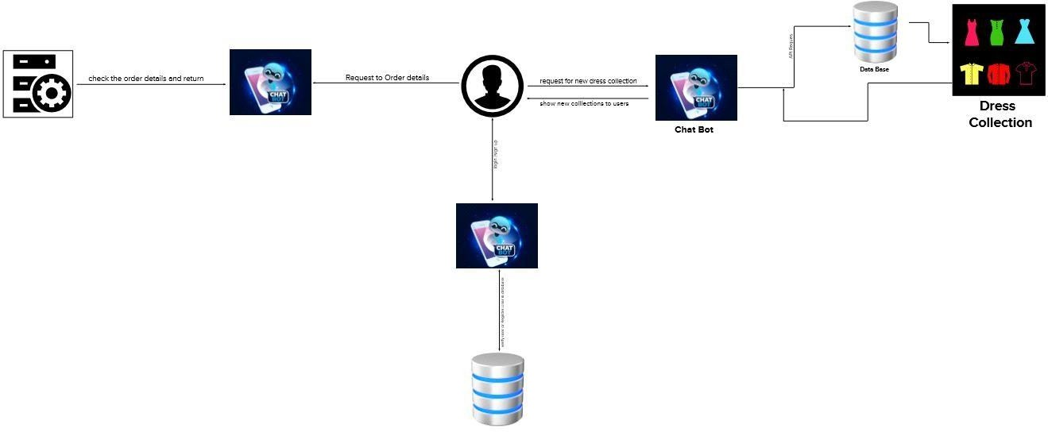

# User Stories

Use the below template to list all the user stories for the product.

|  |  |  |  |  |  |  |
| --- | --- | --- | --- | --- | --- | --- |
| **User Type** | **Functional**  **Requirement (Epic)** | **User**  **Story Number** | **User Story / Task** | **Acceptance criteria** | **Priority** | **Release** |
| Customer (Mobile user) | Registration | USN-1 | As a user, I can register for the | I can access my account / dashboard | High | Sprint-1 |

|  |  |  |  |  |  |  |
| --- | --- | --- | --- | --- | --- | --- |
|  |  |  | application by entering my email, |  |  |  |
|  |  |  | password, and  confirming my password. |  |  |  |
|  |  | USN-2 | As a user, I will receive confirmation email once I have registered for the  application | I can receive confirmation email & click confirm | High | Sprint-1 |
|  |  | USN-3 | As a user, I can register for the application through Facebook | I can register & access the dashboard with Facebook  Login | Low | Sprint-2 |
|  |  | USN-4 | As a user, I can register for the application  through Gmail |  | Medium | Sprint-1 |
|  | Login | USN-5 | As a user, I can log into the  application by entering email &  password |  | High | Sprint-1 |
|  | Dashboard | USN-6 | As a user , I can view the dashboard and by  products |  | High | Sprit -2 |
| Customer (Web user) | Registration / Login | USN-7 | As a user, I can register for the application by entering my email, password, and confirming my  password | I can access my account / dashboard |  | Sprint -1 |
| Customer Care Executive | Application | USN-7 | As a customer care executive i can solve the login issues and other issues  of the application. | As a customer care executive i can solve the login issues and other issues of the  application. | Medium |  |

|  |  |  |  |  |  |  |
| --- | --- | --- | --- | --- | --- | --- |
| Administrator | Check stock and  Price , orders | USN_9 | As a Administrator , I can Check the database  And stock details and buying and selling prices | I am the administrator of the company | High | Sprint -2 |